1.Upgrading WSDL (Web Services Description Language) versions in NetSuite involves several key steps to ensure a smooth transition. Here's an overview of the process:
Review Release Notes
Check NetSuite's release notes for the new WSDL version to understand any API changes, deprecated features, or new functionalities.
- We have reviewed the release notes, and these are the six latest supported endpoints.
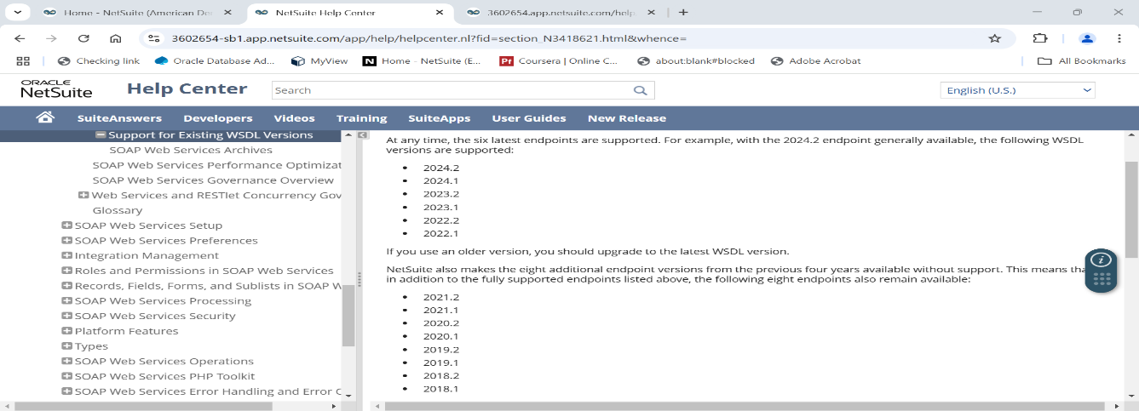
Identify potential impacts on your existing integrations.
2. Backup Current Environment
Create a backup of your current scripts, integration code, and configuration to ensure you can revert if necessary.
- We have reviewed the integrations and identified several integrations:
- MS SOAP Web Services Integrations (2023_1)
- Adaptive Insights Integration (2022_1)
- UltiProConnectTBAIntegration (2019_2)
- InformaticaTBAIntegration(2019_2)
- Concur connector (2022_1)).
- However, we did not make any updates on our end, as these integrations require credentials to create records (e.g., MuleSoft, Java).
3. Access the New WSDL
Navigate to Setup > Integration > Web Services Preferences in NetSuite.
Download the latest WSDL file for the new version.

- We have followed this path but did not find any new WSDL file. Please find the attached screenshot below for reference. 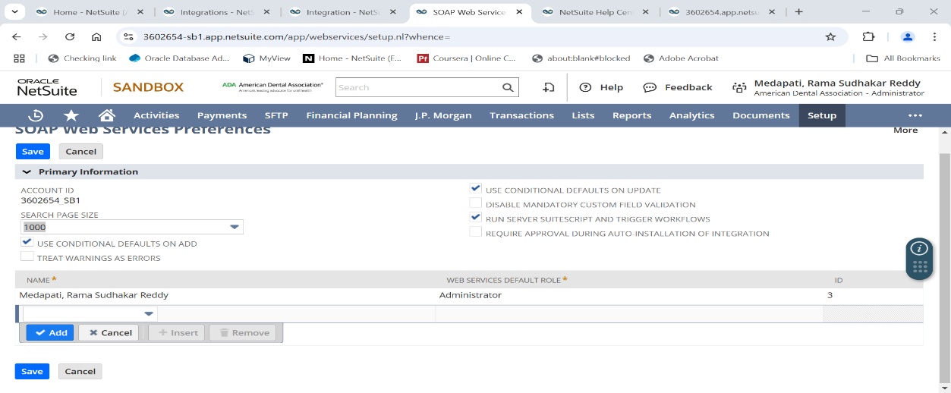
4. Update Integration Code
Update the WSDL URL in your integration code to point to the new version. The URL will typically look like:
https://webservices.netsuite.com/wsdl/v<new_version_number>_0/netsuite.wsdl
Regenerate client stubs if your development platform requires it (e.g., Java, .NET).
- As per the review of the release notes, the latest WSDL version is 2024.2. We found these WSDL URL links in the NetSuite Help Center and have attached them below. These links are being updated on other integration platforms like MuleSoft, Java, etc.
- Please refer below link for your reference:
https://3602654.app.netsuite.com/app/help/helpcenter.nl?fid=section_n3418339.html
5. Adapt to API Changes
Review the new WSDL schema for any changes in object structures, field names, or data types.
Update your integration code to accommodate these changes.
Reviewing WSDL Schema:
- The Integration team will be responsible for reviewing the new WSDL schema for any modifications in object structures, field names, or data types. This step ensures that the integration remains compatible with the latest version.
Updating Integration Code:
- Based on the identified changes, the Integration team will update the integration code to accommodate these new object structures and data types.
Support and Guidance from NetSuite:
- Our team will provide support by sharing necessary links and documentation related to NetSuite updates and any other assistance required during the transition.
- Here I am attaching WSDL Schema link for your reference:
https://suiteanswers.custhelp.com/app/answers/detail/a_id/10824/loc/en_US

6. Test the Integration
Perform thorough testing in a NetSuite sandbox environment to ensure compatibility.
Validate all critical operations, such as record creation, updates, searches, and custom workflows.
- We are prepared to provide support and the necessary syntax for creating, searching, and updating customer records to the Integration team like (MuleSoft, Java). Attached below are the links for critical operations and syntax.
https://suiteanswers.custhelp.com/app/answers/detail/a_id/11001
7. Handle Deprecated Features
Address any deprecated fields or services by replacing or removing them as necessary.
- Our team will provide support by sharing necessary links and documentation related to NetSuite updates and any other assistance required.
8. Implement Error Handling
Enhance error handling mechanisms to capture and address any new error codes or response changes introduced in the new version.
- Our team will provide support by sharing necessary documentation or changes related to NetSuite updates and any other assistance required.
9. Deploy to Production
- Once testing is complete, deploy the updated integration to the production environment.
Monitor the integration closely for any issues.
10. Document Changes
- Document all changes made during the upgrade process for future reference and troubleshooting.
By following these steps, you can ensure a successful upgrade to the latest WSDL version in NetSuite while minimizing disruptions to your integration.


